**Python program to Convert Image into sketch**

**REQUIREMENT FOR THE PROJECT:**

1. NumPy: A fundamental package for scientific computing with Python. It provides support for large, multi-dimensional arrays and matrices, along with mathematical functions to operate on these arrays.
2. Imageio: A Python library that provides an easy interface to read and write images in various formats. It is a versatile library that supports a wide range of image file formats and can be used for tasks such as reading images from files, writing images to files, and displaying images.
3. scipy.ndimage: A submodule of the SciPy library that provides functions for multidimensional image processing. It is particularly useful for tasks related to image analysis, signal processing, and mathematical morphology. The module contains a variety of functions for manipulating and analyzing n-dimensional arrays, which can represent images, volumes, or general data.
4. OpenCV (opencv-contrib-python): Open Source Computer Vision Library. It provides a wide range of tools for computer vision tasks, such as image and video processing.

**STEPS TO EXECUTE THE PROJECT:**

1. Import all the required modules
2. Take image input and assign variable to it
3. Use function to convert image into sketch
4. If image is greater than 255 (which is not possible) it will convert it to 255
   * convert any suitable existing column to categorical type we will use aspect function
5. Convert into a blur image
6. Convert an image from one color space to another
7. Sharp edges in images are smoothed while minimizing too much blurring
8. Converted image is saved

**IMAGE:**

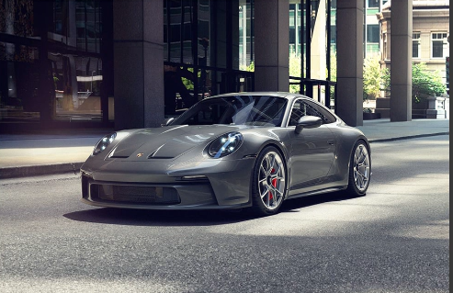

**BLUR IMAGE:**

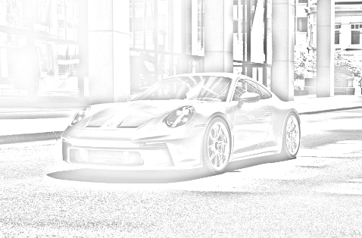

**SKETCH:**

